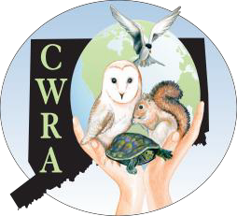

CW RA
Connecticut Wildlife Rehabilitators Association, Inc.

Membership: 10 Hickory Hill, Chester CT 06412

Scan and send completed form to Laurajsimon999@gmail.com
Emergency Grant Form:
This form must be fully completed before grant application will be considered.

Name: Affiliation:

Address: _______

Contact No: Contact E-mail: _____

Supplies Needed: Please specify supplies needed (milk replacer, etc., including brand/type)

Statement of Financial Need: Please specify what financial hardship necessitates this emergency grant and WHY you need these emergency supplies. Please specify how many animals you have in your care.

Experience: Please provide a summary of your rehabilitation background and your species experience applicable to this emergency grant:

Annual Efforts: Please provide an estimation of the total number of animals you handle on an annual basis:
Raccoons Skunks Songbirds Waterfowl Fawns Squirrels Rabbits Opossums Woodchucks Foxes Other

How much do you spend annually for rehabilitation? __ Do you collect donations? Yes No
How much do you receive annually from donations in money or supplies?

I affirm that due to my financial situation an emergency grant is needed. I agree to use the supplies I receive for the exact purpose and according to the terms outlined in this application.

Signature: Date:

Date: Approved:
CWRA Only:
Member-in-good-standing: Yes No
Amount / What Approved:

